February 24, 2026

MS. NAOMI M. TENECIO
State Auditor IV
Audit Team Leader
Commission on Audit
Regional Office No. XIII
Butuan City

Dear Auditor,

Greetings!

In compliance with Section 6.06 of COA Circular No.2012-001 dated June 14, 2012, we are submitting herewith a copy of Inspection and Acceptance Report for the procurement of goods and services delivered by THE POTTER’S HOUSE BY CHINYU for the tokens: LIKHAng Kababaihan Regional Screening on February 24, 2026 at DMW Regional Office XIII Training Hall, Butuan City, to wit:

- Statement of Account
- Charge Invoice
- Inspection and Acceptance Report
- Purchase Order

Hope you find the attached documents in order.

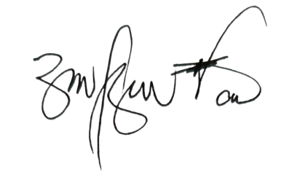
Thank you and best regards

RITCHEL M. BUTAO
Regional Director

